SAFETY REGULATIONS

Dear Customer!
You have purchased a quality product from MANIX and are the owner of a handy and brand-name unit.
Please read the following safety regulations and operation instructions carefully. This will minimize any risk of injury to yourself and allow you to become familiar with correct use of the unit. Please note!

MANIX IS NOT LIABLE FOR CLAIMS FOR DAMAGES ARISING FROM:

• Improper use of the unit
• Applications which are not cited in the instructions
• Failure to observe the safety regulations

The GUARANTEE IS INVALIDATED IN THE EVENT OF:

• The unit is used improperly
• Inadequate maintenance
MANIX reserves the right to make further developments in the interests of technological advance.

IMPORTANT!

• Ensure the workplace is tidy.
• Check the unit for damage before use (connection cable, protective devices, etc.),have defective -parts replaced by qualified personnel.
• This unit corresponds to the pertinent safety regulations. Repairs
(e.g.,replacement of the power supply lead) may only be perform-med by a qualified electrician
• Never work without the safety equipment fitted.
• Do not use electrical power tools in the rain, in damp surroundings or in the vicinity of flammable liquids or gases.
• Only use the tool when the handle is dry and free from grease.
• Avoid contact with earthed components, e.g.,pipes, radiators, ovens and
refrigerators.
• Protect the connection lead from heat and sharp edges and route it so it cannot be damaged.
• Do not remove the plug from the socket by pulling on the cable.
• Do not pick up the unit by the cable.
• Keep children and third parties away from the workplace.
• Keep tools in child-safe locations when not in use.
• Do not overload the tool.
• Do not use the tool to perform operations for which it is not suitable.
• Replace blunt tools in good time.
• Visually inspect application tools to ensure they are in good working order and suitable for the task prior to setting up the job.
• Fasten tools securely.
• Clean the unit thoroughly following all work (disconnect the power supply plug).
• Disconnect the plug from the power supply when the unit is not in use, before performing maintenance, tool replacement or repair work.
• Only plug the unit in when the unit is switched off.
• Always wear protective goggles (danger of tool breakage).
• If necessary, wear a protective dust mask.
• Only use appropriate working clothes (no loose sleeves, ties, jewellery).
• Only use accessories and spare parts recommended by MANIX (Observe the max. permitted rotational speed).
• If necessary, use dust extract equipment (only use suitable dust extract equipment)/ explosive hazard through sparks).
• Do not use the tool when you are tired or under the influence of alcohol. Keep fingers away from rotating or fast-moving tools (saws,etc.).
• Keep the operation instructions in a safe place.

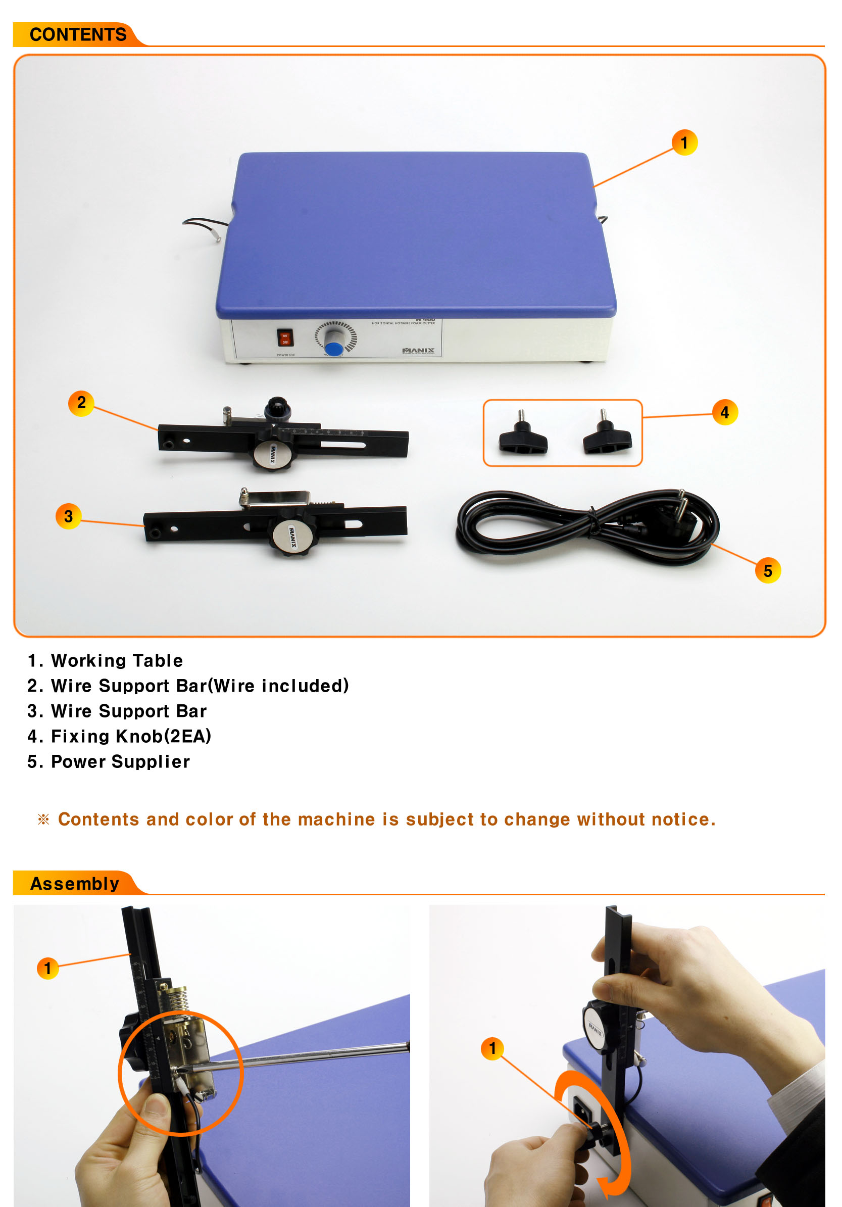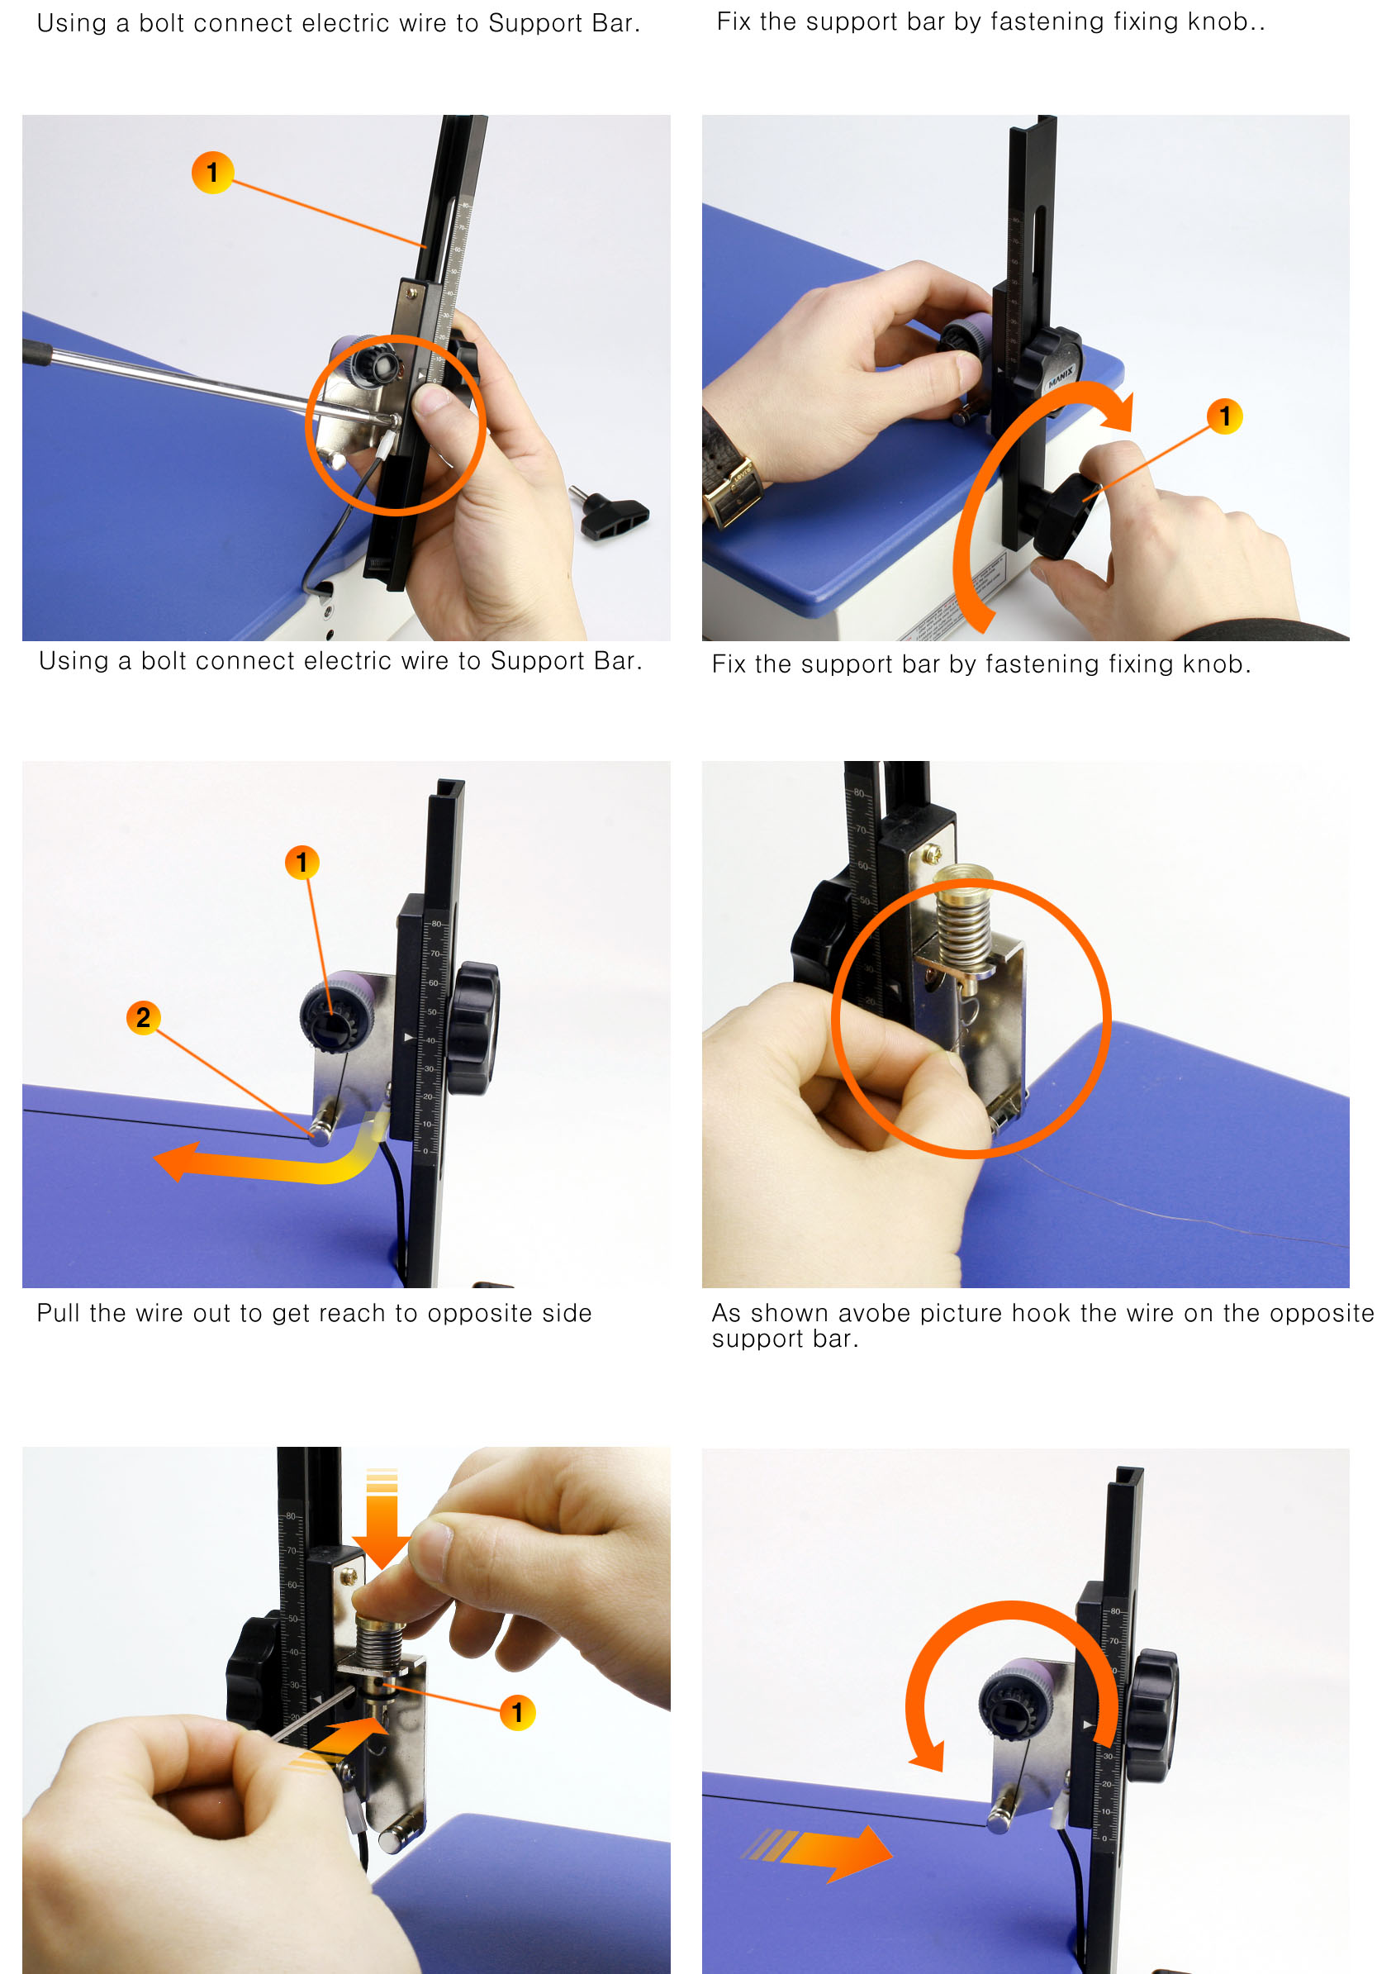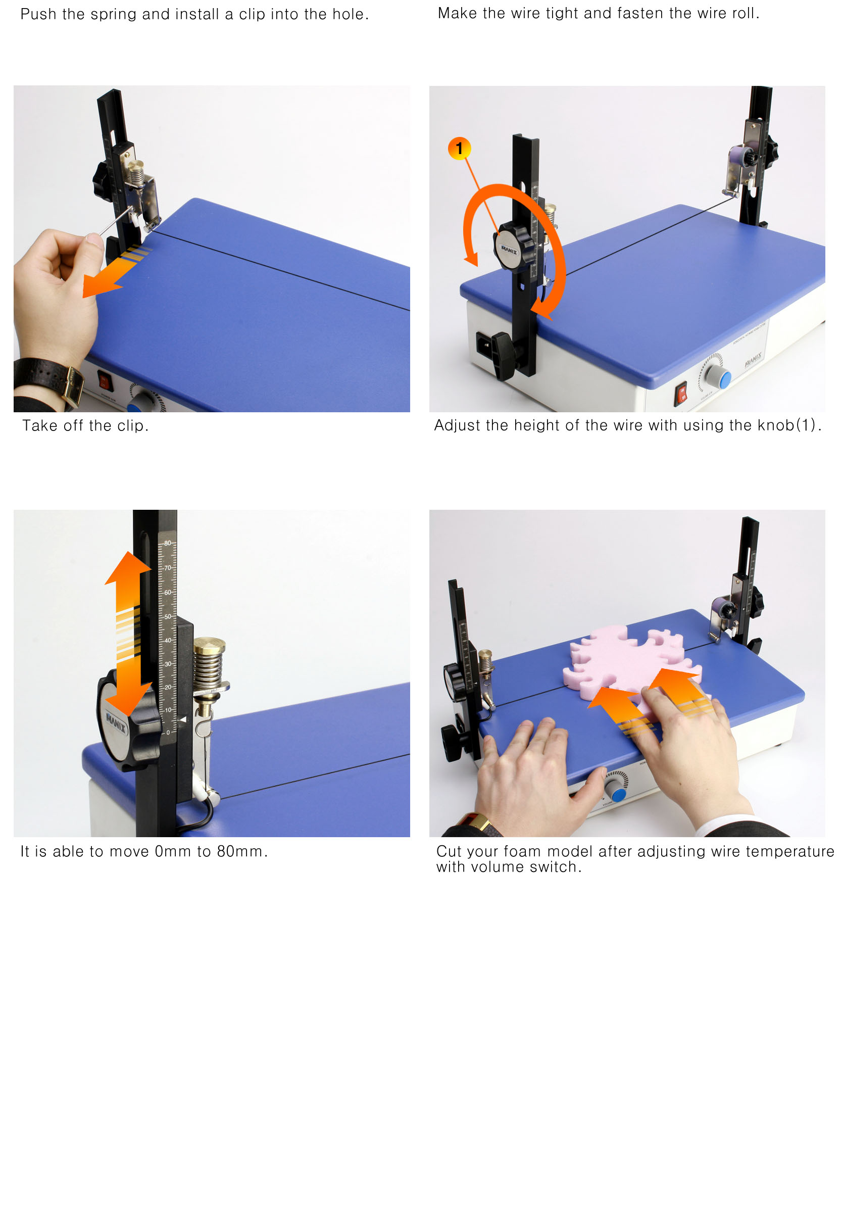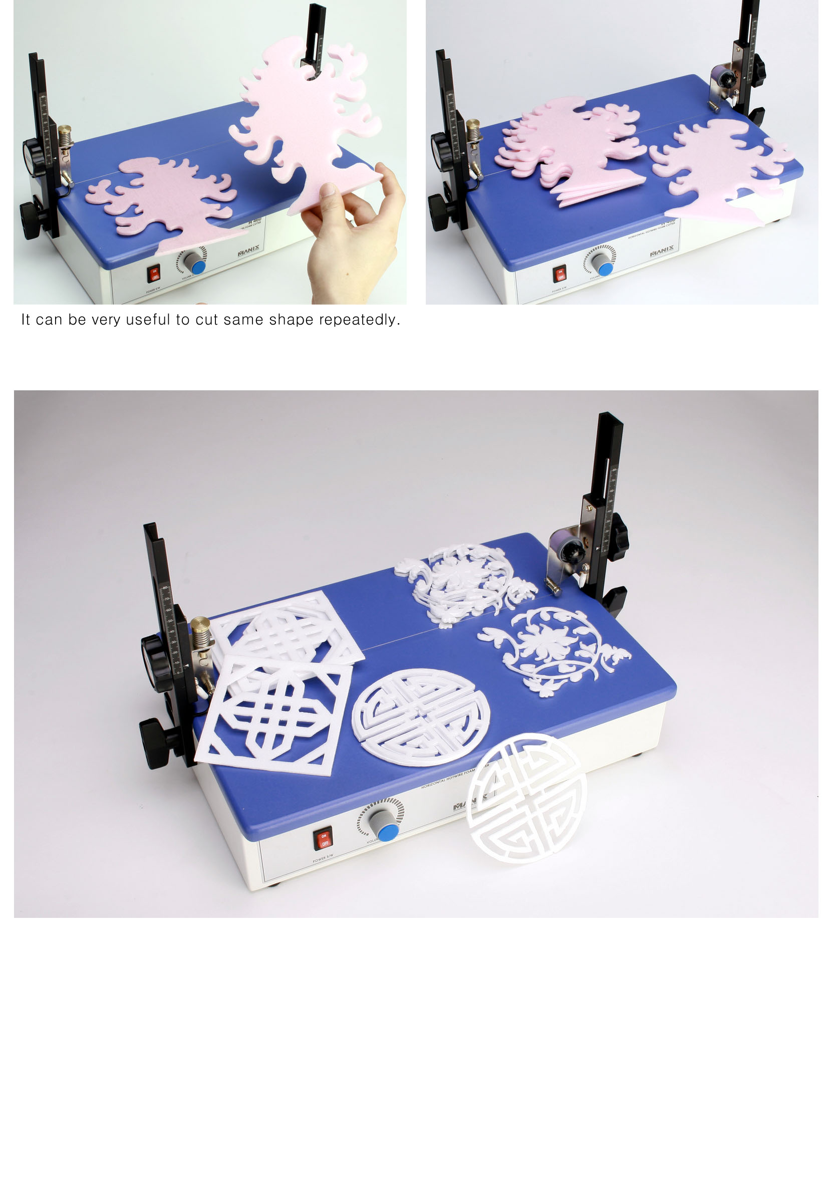- SPECIFICATONS
WORKING SIZE | 450X250
CUTTING HEIGHT | 1~80mm
WIRE DIAMETER | 0.23Ø
DIMENSIONS | 450X250X250(mm)
WEIGHT | 5 KG

